**IN SCOPE**

* It will be validated that the user can register in the LendingFront platform and a unique identifier will be created.
* It will be validated that the user can log in to the LendingFront platform.
* It will be validated that when the session is started, the current status of the application is observed ("Under review", "Verification", "Document preparation", "Approved", "Denied").
* It will be validated that when a session is started and a loan has been requested, the status of the loan is observed ("Active", "Closed").
* It will be verified that when a loan has been approved, it was observed: the balance of the loan, the payment activity and the pending payments.
* It will be verified that the application allows proactive payments regarding the loan through credit cards or bank accounts.
* It will be verified that the application keeps track of the accounts used previously and they are presented as an option.
* It will be verified that the platform supports multiple languages and currencies.
* It will be validated that when a loan is financed, the application begins to collect payments.
* It will be validated that the application generates a file with all the due payments and is sent to the ACH network.
* The sending of the funds to be deposited in the Client's bank account will be verified.
* It will be verified that the application has updated the status of the payments in the generated file.
* It will be validated that the application can generate different reports such as:
  + Loan status
  + Late payments.
  + Pending applications

**OUT OF SCOPE**

* The internal operation of the ACH network will not be tested.

**RISK MATRIX**

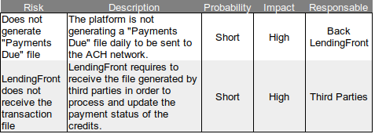

**PREREQUISITES**

* User accounts are required as test data, with variations in credit applications to be able to validate the different status and payment activity.
* A credit card or bank account simulator is required to check various functionalities of the application such as proactive payments.
* Access to the files generated by the application is required to verify the information.
* Access to some infrastructure components such as a Database is required to verify the preservation of the information.
* A stable test environment is required.

**ASSUMPTIONS**

Testing environment available from third parties like ACH.

**INFRAESTRUCTURE**

* Stable test environment is requested with the application deployed.
* A device farm is requested for automated tests in parallel with different browsers.

**STRATEGY**

Automated regression tests will be developed after an analysis and review of the test cases that have been documented by manual testers. This review will consist of selecting the most repetitive test cases that are part of the critical path, initially carrying out the development of the automation of the happy path and then the alternate cases.

The automation project will be configured to support the execution of the automatic tests in a device farm with different browsers and I managed to carry out parallel executions.

The automated tests will have the ability to generate a report of the test cases executed and indicate the error found.